Skip Point

2. Homepage - Take A Tour Section Missing

4. Footer - Top ke jagah par woh brain wala Icon dikhana hai

6. Services Page - Service Details page me alignment ka problem hai

7. FAQ's Page is not working in both websites

12. Homepage - Who we are? - make it in 5 lines

13. About Page - Who are we? section - Pointers highlight hona chaiye

15. About Page - What we do? section - We are open to discuss with - Pointer ka design circle with arrow chaiye

16. About Page - Meet the Directors - Learn More Button Color

18. About Page - Our Experienced Team - Know More Button Color

19. About Page - Meet the Directors - Questions? Write to - make it bold use :

20. About Page - Meet the Directors - Questions? - info@mentalstrengthprofessional.com - Please use same blue color and make clickable. Hover ka bhi dekhna same hona chaiye

23. Service Deatails - Counseling - Left Size zyaada liya hai

Need this

8. Homepage - How to be positive section is not working

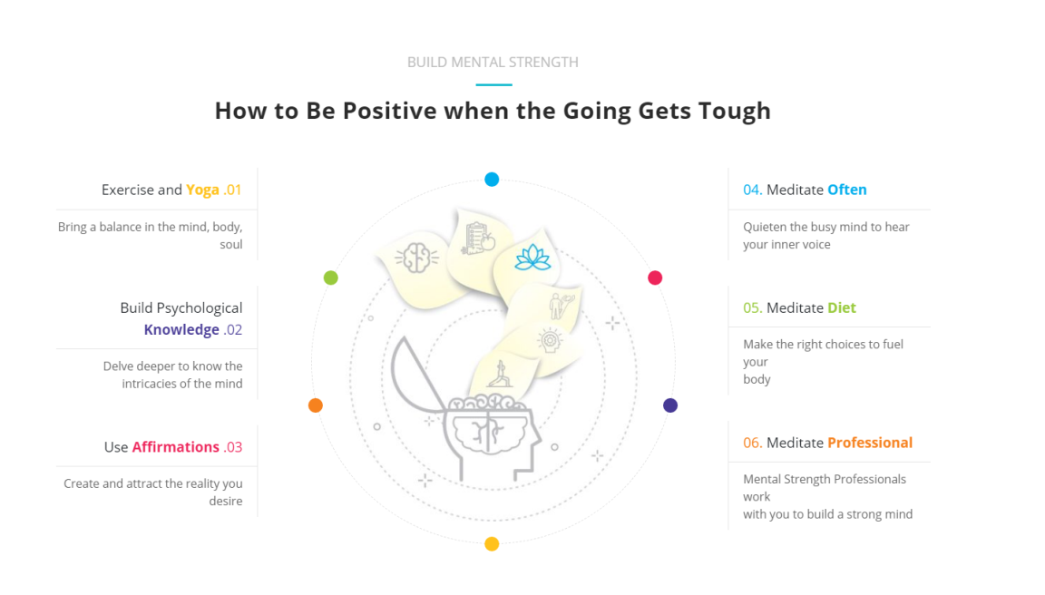

hover black and white image

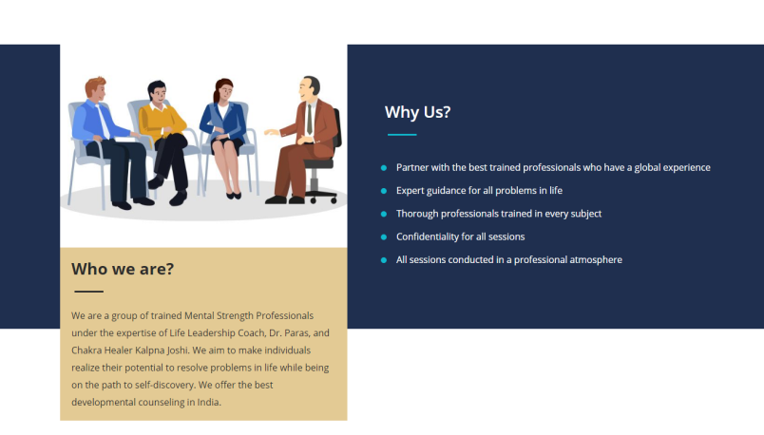

overflow menu

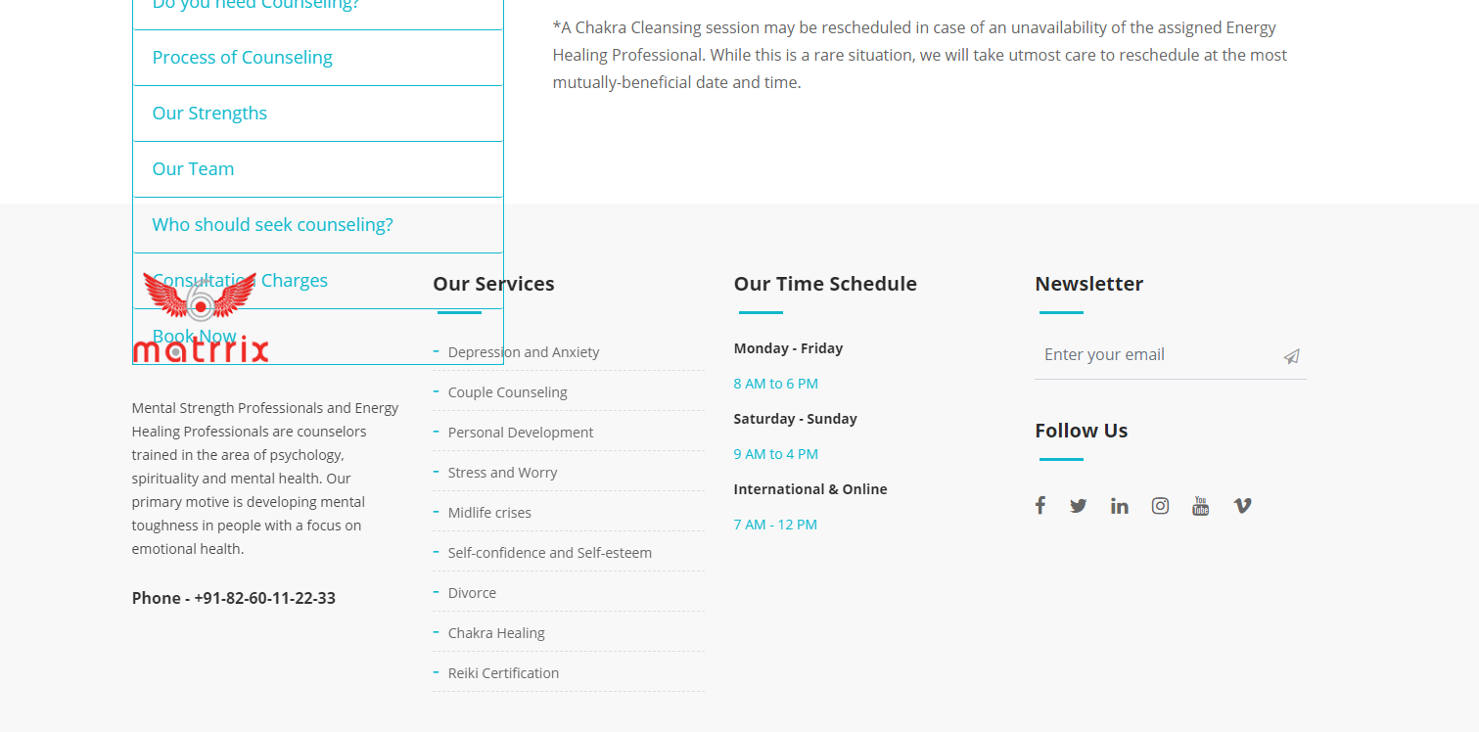

video not working safari browser

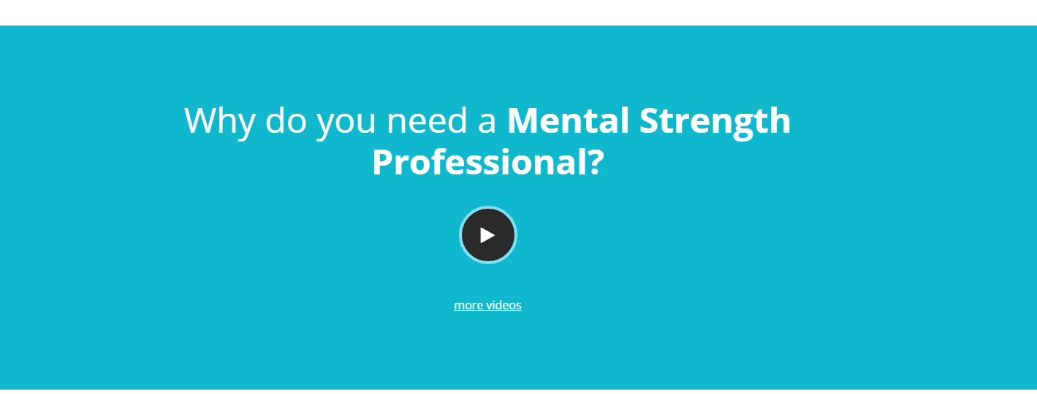

Updated

MSP:

1. For All pages please check the font size

3. Homepage - Best Mental Strength wala section(Please check Screen Shot)

5. Footer - Terms and Conditions To Top ek sath dikhta hai

9. Fix An Appointment Form - Use word Message instead of Messages

10. Homepage - Why Us Section - Space zyaada use kiya hai

11. Homepage - Self-Care Section - Click Here - https://psychometricassessments.com/test-detail.php?name=44-Mind-Body-Well-Being-Assessment-MBWA

14. About Page - What we do? section - make this line Italic - So, the tough get going.

17. About Page - Self-Care Section - Click Here - https://psychometricassessments.com/test-detail.php?name=44-Mind-Body-Well-Being-Assessment-MBWA

21. About Page - Self-Care Section - Click Here - https://psychometricassessments.com/test-detail.php?name=44-Mind-Body-Well-Being-Assessment-MBWA

22. Services Page - Chakra Healing Image

24. Service Deatails - Counseling - info@mentalstrengthprofessional.com - Please use same blue color

25. Service Deatails - Counseling - info@mentalstrengthprofessional.com - link is not working. Hover ka bhi dekhna same hona chaiye

26. Service Deatails - Counseling - Take a tour and click here - link is not working. Hover ka bhi dekhna same hona chaiye

27. Service Deatails - Counseling - Pricing - info@mentalstrengthprofessional.com and Click here - Please use same blue color

28. Service Deatails - Counseling - Pricing - info@mentalstrengthprofessional.com and Click here - Link not working. Hover ka bhi dekhna same hona chaiye

29. Service Deatails - Chakra Healing - Benefits of Chakra Healing and Cleansing - Please remove this 4 points

Wish to delve deeper into your personality

Find your life’s purpose

Face an identity crisis, sexual orientation

Career growth

30. Service Deatails - Chakra Healing - Types of Packages Available - a and b point ke bichme gap zyaada hai

31. Service Deatails - Chakra Healing - Who should opt for Chakra Cleansing? - info@mentalstrengthprofessional.com - Please use same blue color and make clickable. Hover ka bhi dekhna same hona chaiye

32. Service Deatails - Reiki Certification - What is Reiki Certification all about? - The completion of 3 levels and Work on goals with a fresh perspective - Put Space between

33. Service Deatails - Reiki Certification - What is Reiki Certification all about? - info@mentalstrengthprofessional.com - change color and make clickable. Hover ka bhi dekhna same hona chaiye

34. Service Deatails - Reiki Certification - \*Those who - Pehele Space nahi chaiye

35. Service Deatails - Reiki Certification - Be a Reiki Teacher - info@mentalstrengthprofessional.com - change color and make clickable. Hover ka bhi dekhna same hona chaiye

36. Service Deatails - Reiki Certification - Be a Reiki Teacher se pehele space aana chaiye

37. Service Deatails - Reiki Certification - Process of Reiki Healing - info@mentalstrengthprofessional.com - change color and make clickable. Hover ka bhi dekhna same hona chaiye

38. Service Deatails - Reiki Certification - Our Team - Read more and info@mentalstrengthprofessional.com - change color and make clickable. Hover ka bhi dekhna same hona chaiye

38. Service Deatails - Reiki Certification - Who should opt for Reiki Healing? - Click here - change color and make clickable. Hover ka bhi dekhna same hona chaiye

39. Service Deatails - Reiki Certification - Consultation Charges - Please check space nahi hai dono sentence me

40. Service Deatails - Reiki Certification - \*A Reiki Healing - Book Now ke baad space aayega

41. Service Deatails - Reiki Certification - \*A Reiki Healing - info@mentalstrengthprofessional.com - change color and make clickable. Hover ka bhi dekhna same hona chaiye

42. Contact Page - Use word Message instead of Messages

MSP Meta Tags:

Home Page -

Title: Mental Health Counselling in India | Mental Strength Professionals

Description: Get the best treatment for depression, developmental counseling, and more by Mental Strength Professionals. Register now.

keywords: best treatment for depression, best marriage counsellor in mumbai, developmental counseling, mental health counselling india, spiritual healer in mumbai

About Page -

Title: Developing Mental Toughness | Best Counselors in India

Description: Join our mental strength professionals for developing mental toughness. We offer depression counseling, stress, relationship, career counseling, and more

keywords: developing mental toughness, mental strength training, building mental toughness

Service Page:

Title: Counseling Services in India | Mental Health

Description: Get access to professional counseling services, find ways to manage stress and depression. Book our sessions, now!

keywords: ways to overcome depression, relationship counselling in mumbai, professional counseling, ways to manage stress, how to deal with midlife crisis

Contact Page:

Title: Mental Strength Coaching | Book a Mental Toughness Coach

Description: Book our Mental Strength Coaching Professionals for coaching that builds your mind power.

keywords: mental toughness coach, mental strength coaching